EXPERIMENT 9

USING PULSE WIDTH MODULATION FOR
PRECISION CONTROL OF EXTERNAL MODULES

From:Muhammad Husnain Khalid
Roll No:22l-6286
Class:8A2

To: Muhammad Ahmad

CODE:

#include <stdint.h>
#include "tm4c123gh6pm.h"

unsigned int notes[] = {262, 262, 294, 262, 349, 330, 262, 262, 294, 262, 392,
349, 262, 262, 523, 440, 349, 330, 294, 466, 466, 440,
349, 392, 349};

unsigned short interval[] = {4, 4, 8, 8, 8, 10, 4, 4, 8, 8, 8, 10, 4, 4, 8, 8, 8,
8, 8, 4, 4, 8, 8, 8, 12};

#define PWM_CLK 8000000

void PWM_Init(void);
void PWM_SetNote(uint32_t freq);
void delay_ms(uint32_t ms);

int main(void) {
int i;
PWM_Init();

while(1) {
for(i = 0; i < 25; i++) {
PWM_SetNote(notes[i]);
PWM1_ENABLE_R |= 0x40;
delay_ms(interval[i] * 100);
PWM1_ENABLE_R &= ~0x40;
delay_ms(50);
}
delay_ms(2000);
}
}

void PWM_Init(void) {
volatile uint32_t delay;

SYSCTL_RCGCPWM_R |= 0x02;
SYSCTL_RCGCGPIO_R |= 0x20;
delay = SYSCTL_RCGCGPIO_R;

SYSCTL_RCC_R = (SYSCTL_RCC_R & ~0x000E0000) | 0x00100000;

GPIO_PORTF_AFSEL_R |= 0x04;
GPIO_PORTF_PCTL_R = (GPIO_PORTF_PCTL_R & ~0x00000F00) | 0x00000500;
GPIO_PORTF_DEN_R |= 0x04;
GPIO_PORTF_AMSEL_R &= ~0x04;

PWM1_3_CTL_R = 0;
PWM1_3_GENA_R = 0x8C;
PWM1_3_LOAD_R = (PWM_CLK / 262) - 1;
PWM1_3_CMPA_R = PWM1_3_LOAD_R / 2;
PWM1_3_CTL_R = 0x01;

PWM1_ENABLE_R &= ~0x40;
}

void PWM_SetNote(uint32_t freq) {
uint32_t load = (PWM_CLK / freq) - 1;
PWM1_3_LOAD_R = load;
PWM1_3_CMPA_R = load / 2;
}

void delay_ms(uint32_t ms) {
uint32_t i, j;
for(i = 0; i < ms; i++)
for(j = 0; j < 3180; j++);
}

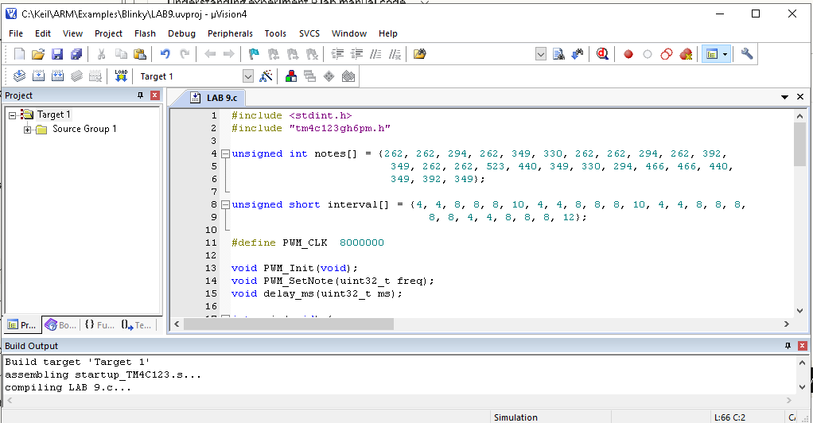

Description
In PWM_Init we enable clocks for PWM1 and Port F, then set the PWM clock to 8MHz by dividing the system clock by 2 through the RCC register. PF2 is configured as alternate function M1PWM6 by setting AFSEL and writing 5 into its PCTL field. Generator 3 is disabled first while we write GENA=0x8C which tells it to go HIGH when the counter hits LOAD and LOW when it hits CMPA, then we start the generator but keep the output pin disabled.
PWM_SetNote just calculates LOAD as (8MHz / freq) - 1 and sets CMPA to half of that to get 50% duty cycle.
In main we loop through all 25 notes, each time calling PWM_SetNote to set the frequency, enabling the output, waiting for interval[i] × 100ms, then disabling the output and adding a 50ms gap so adjacent identical notes don't blend together. After all 25 notes there's a 2 second pause before the song repeats.

